STEM Tutoring and Extra Curricular
Carl Chandler, PhD Physics
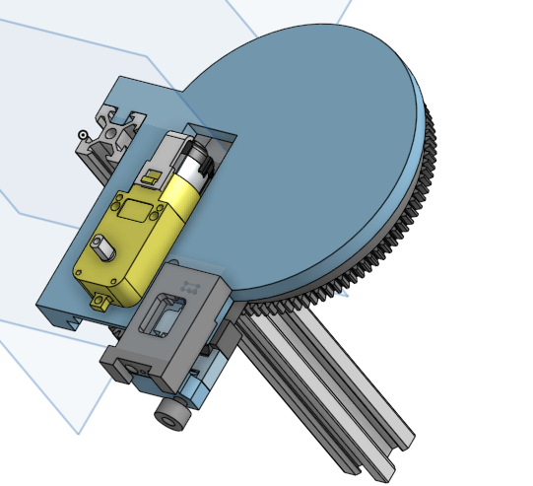
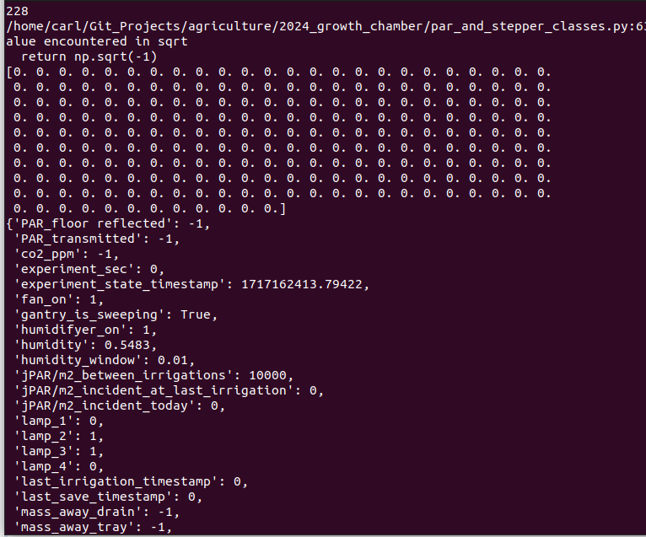
Looking for extra help with Math, Science, Computer Programming in Grades 6-12?

Interested in STEM projects but not sure how to get started, or don’t have a proper workshop/lab space?

Carl has years of experience teaching undergraduates and teens and a broad knowledge base of theoretical physics and mathematics along with practical experience in:
Aquaculture system and experiment design
Electromechanical control systems
Computer programming for physics and engineering simulations
Robotics and embedded programming for Arduino, Raspberry Pi and other micro controllers
Mechanical design, CAD, and prototype construction
Carl currently runs the agricultural focused research company Sun Aquasystems Ltd. in Yarmouth NS and has a well equipped workspace with 3d printers, electronics assembly, and robotics parts library available for student projects. Evening tutoring and extra curricular project time-slots avalible for the 2024-2025 school year on a first come first serve basis.

Contact:
www.sunaquasystems.com/education-and-tutoring/
carljosephchandler@gmail.com
902-307-7435

STEM Club and Tutoring
with Carl Chandler, PhD

Build robots
Perform experiments

Learn to code, make simple games, and control robots

Draw in 3D and manufacture parts with 3D printers

Solder and assemble electronics

Sound like your type of fun?
Grades 6-12
www.sunaquasystems.com/education-and-tutoring/
carljosephchandler@gmail.com
902-307-7435

